**INTRODUCTION.**

**OVERVIEW.**

**A brief description about your project.**

A subscriber to a channel on the video – sharing youtube is a user who has chosen to receive the channels content by clicking on that channels subscribe , button and each users subscription feed consists of videos published by channels to which the user is subscribed.

**PURPOSE.**

**The use of the project. What can be achieved using this.**

* Top youtube channel is comparing the youtube channel that is the most effective and useful tools in the channel.
* This authentic information can be use in job and business will be achived in the life.

**PROBLEM DEFINITION & DESIGN THINKING.**

**Empathy map.**

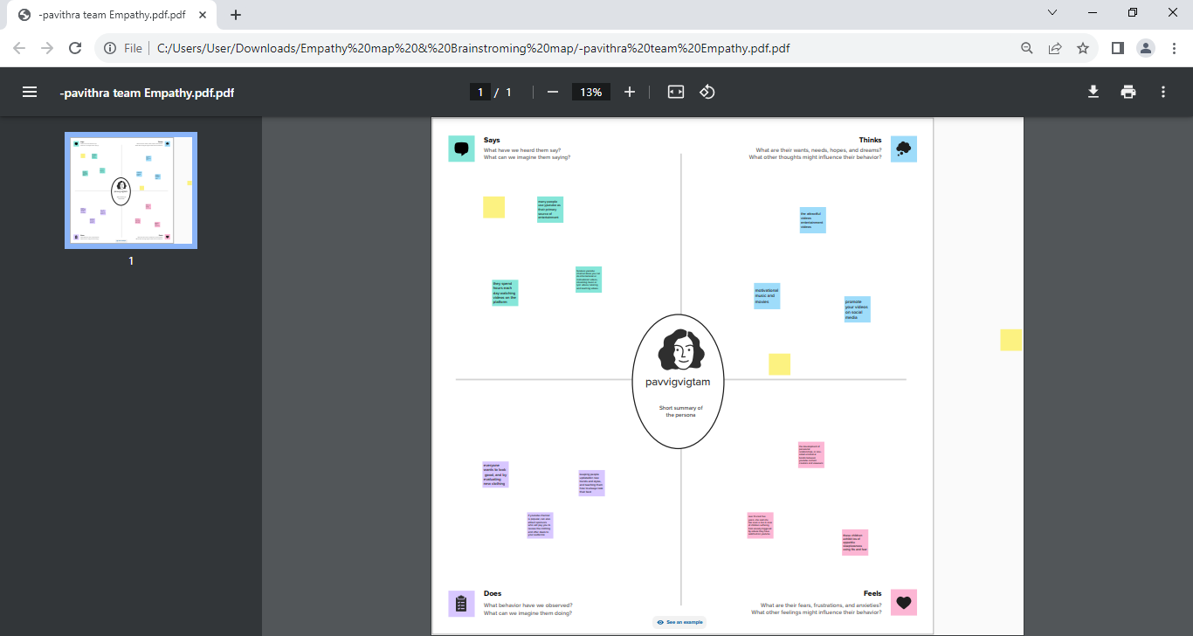

Ide**ation & Brainstroming map.**

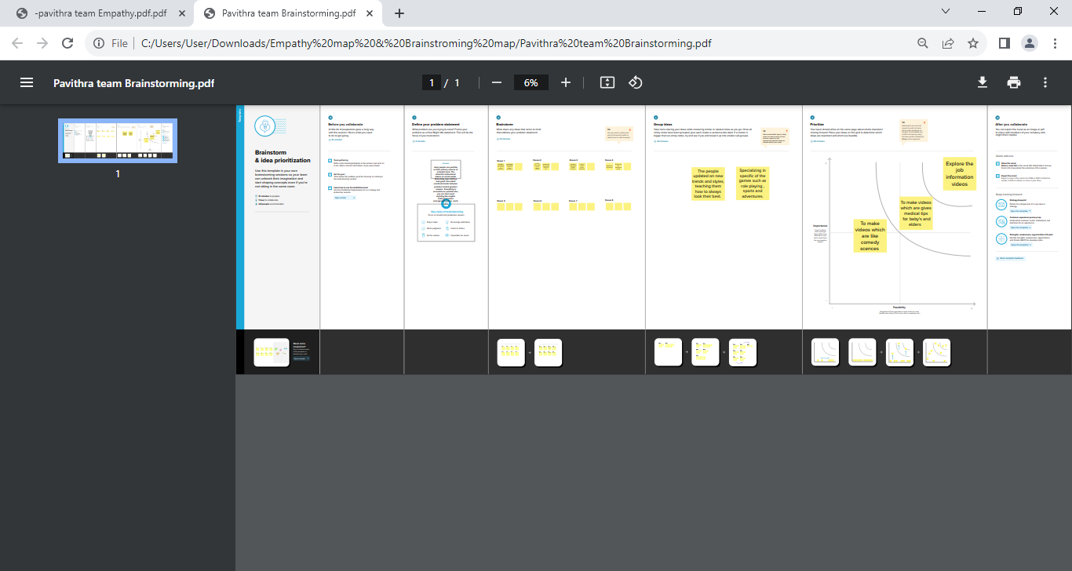

**RESULTS.**

**VISUALIZATION.**

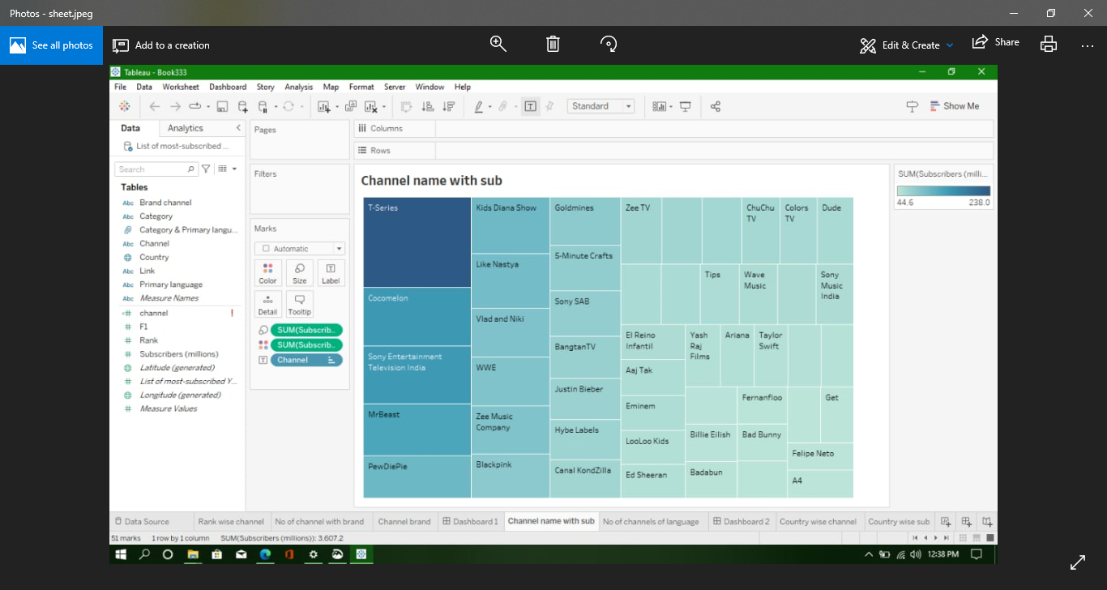

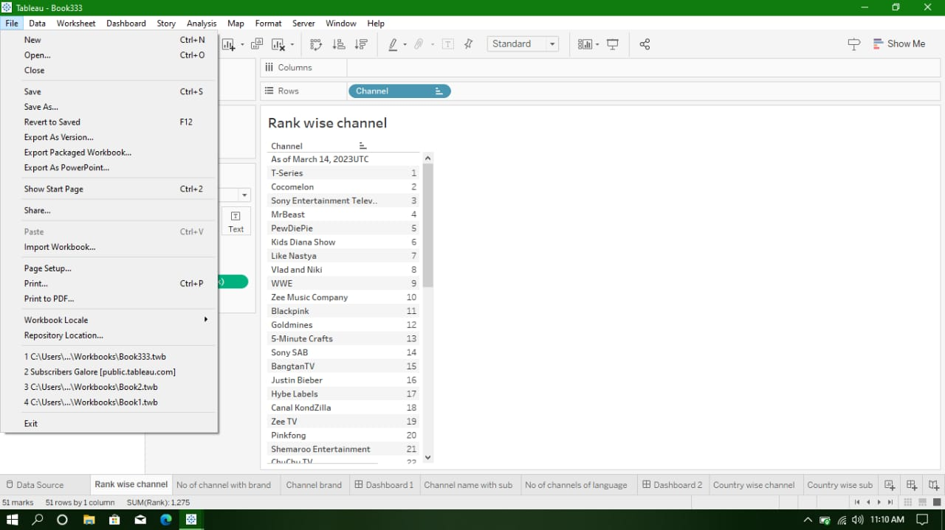

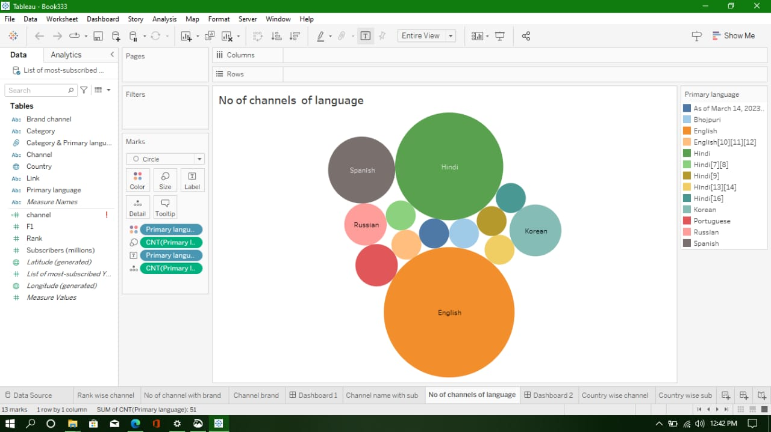

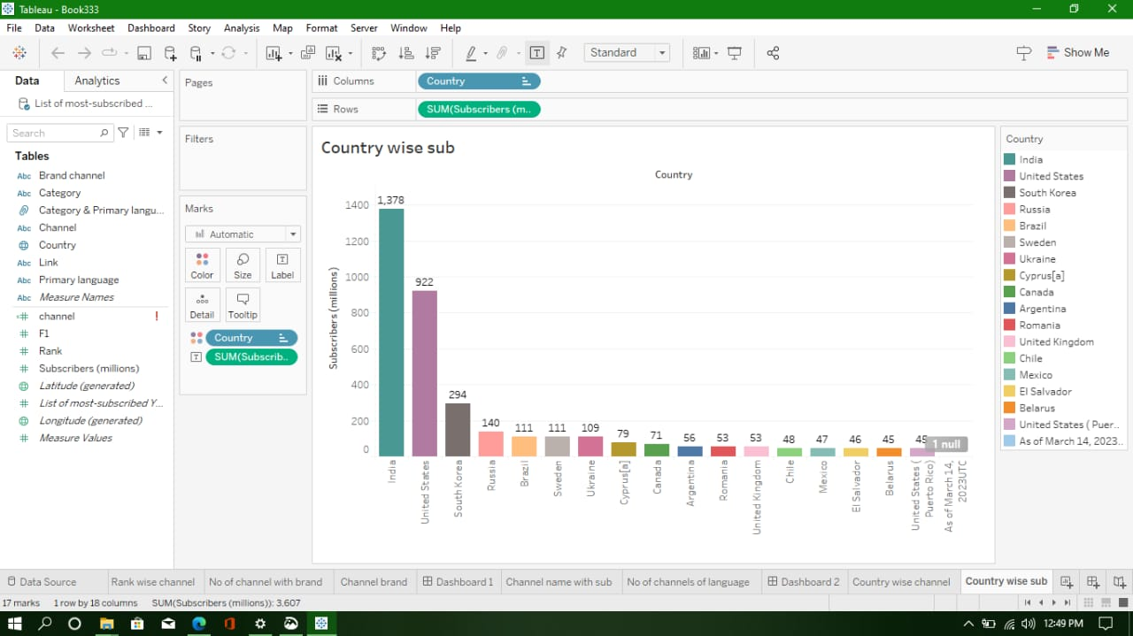

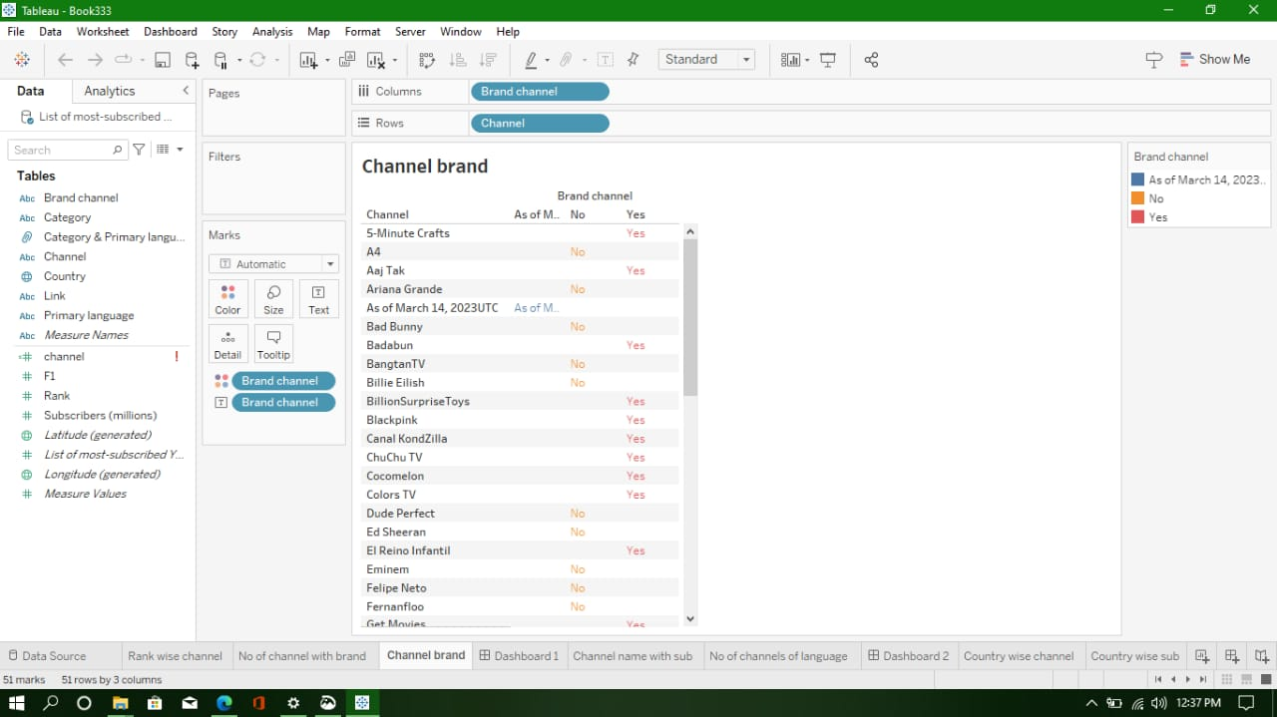

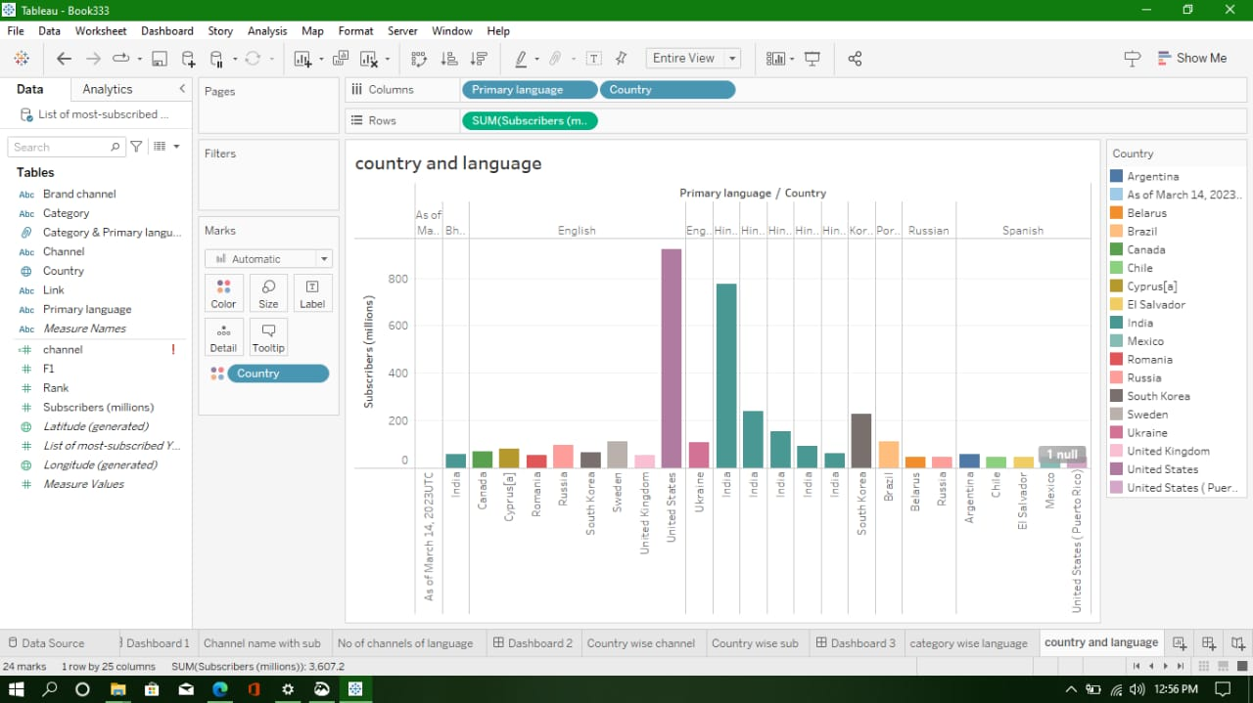

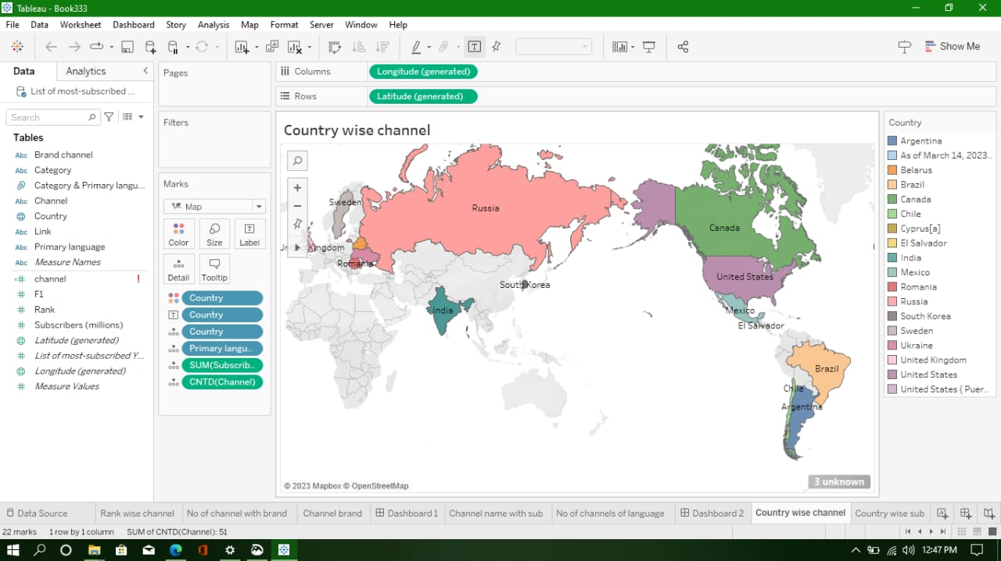

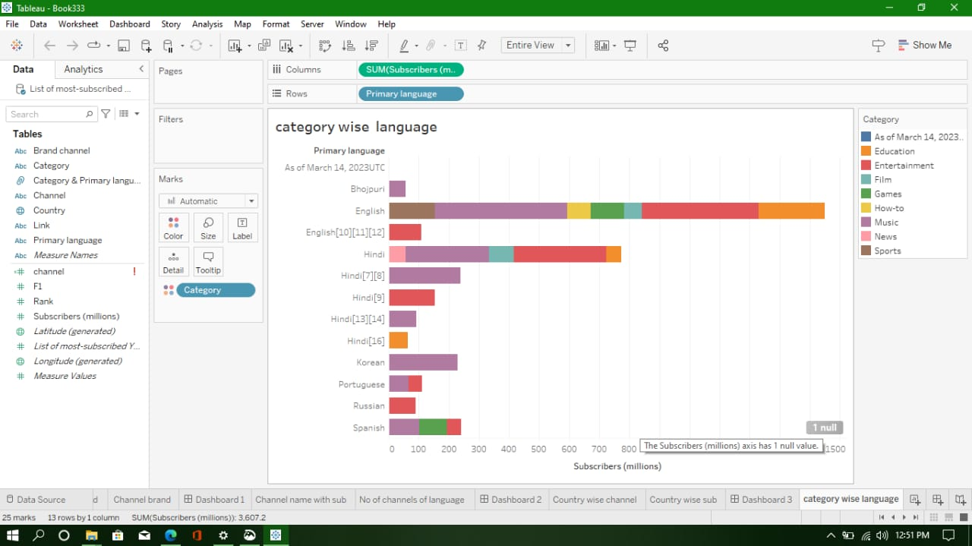



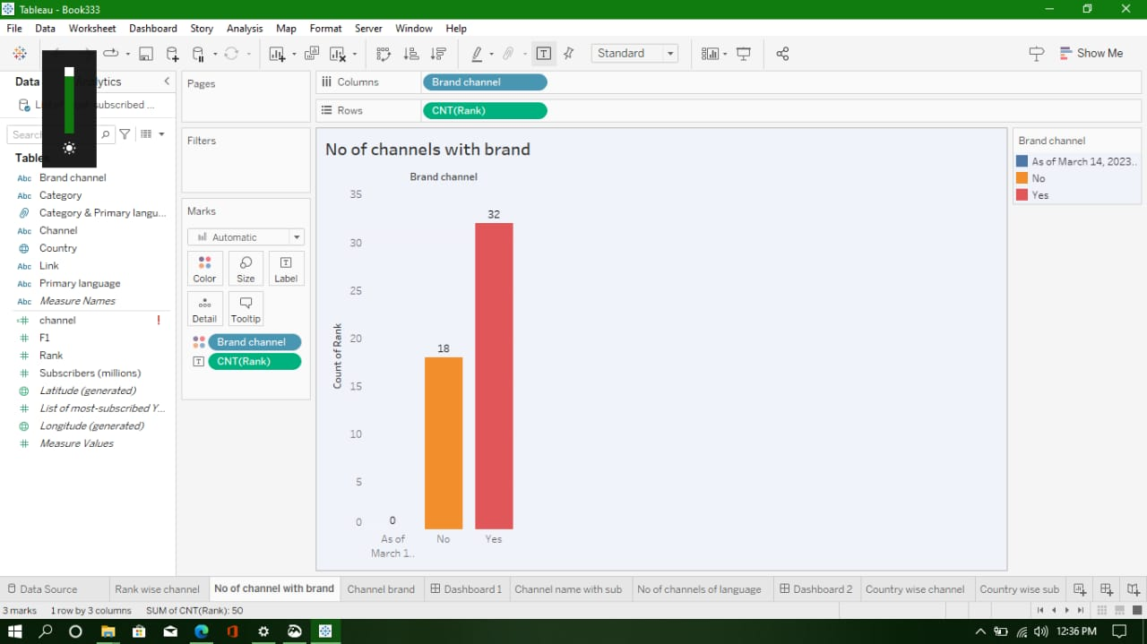

**DASHBOARD.**

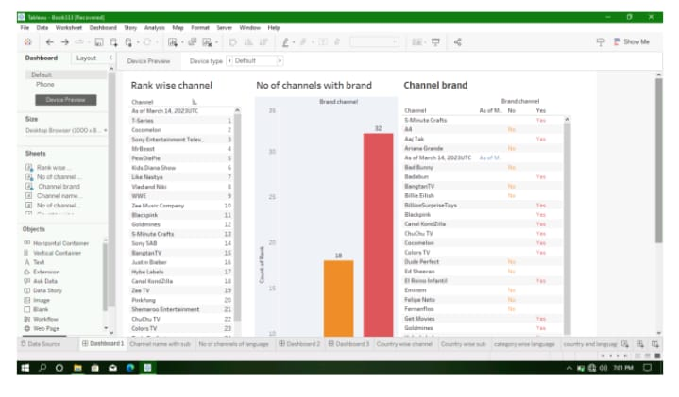

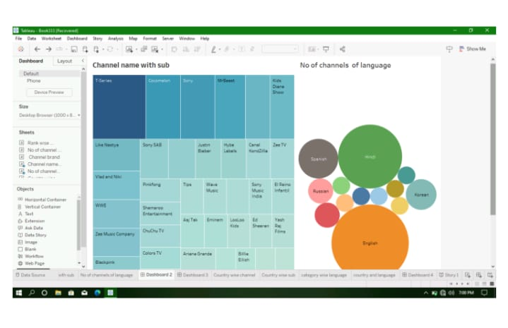

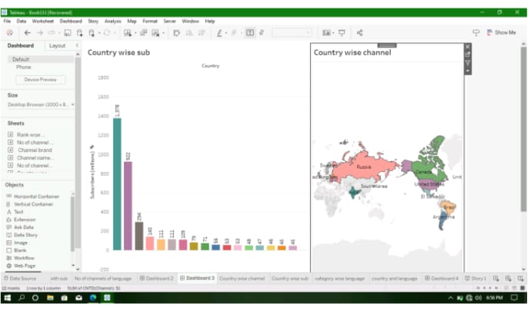

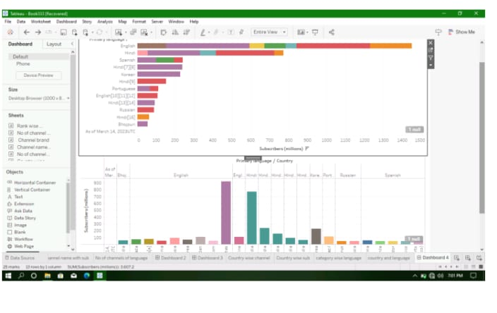

**STORY.**

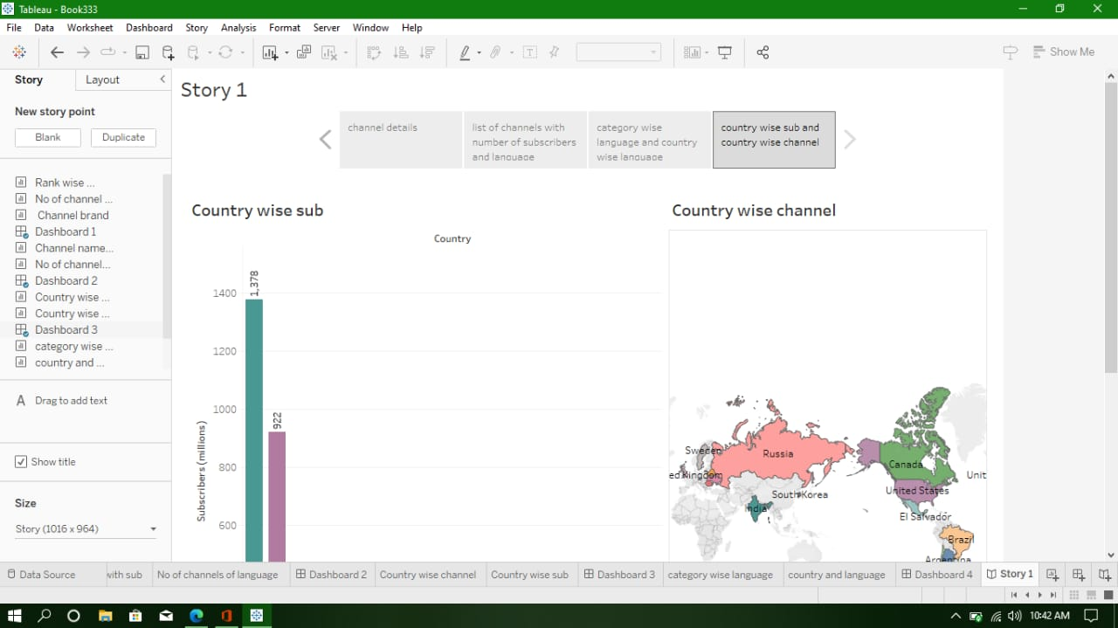

**ADVANTAGES & DISADVANTAGES.**

**List of advantages of the proposed solution.**

Things keeping the people updated an new brands & styles & teaching more then videos updated

In this top youtube channel so is the advantage of the channel.

**List of disadvantages of the proposed solution.**

The subscribers thinking about on the top youtube channel can being not introduced on other

Channel names so there his the disadvantage.

**APPLICATIONS.**

The areas where this solutions can be applied.

Holds the crown as youtube’s most subscribed creator. He can boast a subscribers base of

Over 180 million. While a handful of channels may have more massive audiences,there all

Run by studios rather than individual creators.

**CONCLUSION.**

Youtube is massive & it has been for awhile now . in feburary 2023 alone this video showing

Website was visited over 80 billion times . future more there are currently 30 million channels

On youtube with 15 million of them being creators.

**FUTURE SCOPE.**

The upcoming generation useful and helpful videos and social massages all above the videous

In updates.